Clinical Mental Health Counseling Program
Neumann University
2024-25 Annual Report

The Clinical Mental Health Counseling (CMHC) Program at Neumann University is a 60-credit, CACREP accredited master’s program. The program is evaluated in a variety of ways, including a program assessment plan, demographic data on applicants, students, and graduates, and data from follow-up studies of key stakeholders. Program outcomes are evaluated through a Program Assessment Plan, created in conjunction with the Office of Institutional Research. This report outlines the findings of the different evaluation measures from Fall 2024-Summer 2025 as well as program modifications and substantial program changes.

New Assessment Plan and Evaluation of Program

Across the Fall 2024-Summer 2025 year, the CMHC Program designed and implemented a new Assessment Plan in response to CACREP feedback. The new plan is delineated within an “Assessment Handbook” and identifies five Program Objectives (POs) and ten Student Learning Outcomes (SLOs) with two Key Performance Indicators (KPIs) for each of the latter. The five POs are:

PO1. The CMHC department will recruit, admit, retain, and graduate a diverse student body.
PO2. The CMHC department will provide meaningful education to students to prepare them with the core counseling knowledge and practical skills necessary for employment as a clinical mental health counselor.
PO3. The CMHC department will prepare students to work ethically in diverse settings with adherence to multi-cultural counseling guidelines.
PO4. The CMHC department will prepare students with the necessary skills and knowledge to address future clients’ spiritual needs.
PO5. The CMHC department will prepare students for employment, licensure, and certification as a clinical mental health counselor.

The ten SLOs are:

SLO1. Identify as a professional counselor in alignment with ethical and legal standards.
SLO2. Develop skills to work with diverse clients which includes attention to issues of diversity, equity, inclusion, and belonging in counseling.
SLO3. Incorporate knowledge of models for development across the lifespan to promote wellness and optimal development.
SLO4. Learn and apply career development models and assessment tools to address client’s vocational needs.
SLO5. Acquire and demonstrate basic counseling skills while employing a major counseling theory.
SLO6. Learn and apply knowledge of group dynamics and group counseling skills.
SLO7. Apply a working knowledge of assessment to assess client problems and to effectively treat clients.
SLO8. Learn and apply research strategies and statistical knowledge to improve client treatment and program outcomes.
SLO9. Demonstrate the skills to effectively serve clients in the clinical setting which includes assessment, diagnosis, and clinical treatment.
SLO10. Demonstrate culturally responsive professional behaviors that display self-regulation, self-awareness, flexibility, openness to feedback, and motivation to learn and grow.

These new POs and SLOs are defined in our program’s Assessment Handbook with measurable data points that can be collected, assessed, and evaluated across time. The results from this first year of implementing this new Assessment Plan follow below.

Program Assessment Plan Results
PO1. The CMHC department will recruit, admit, retain, and graduate a diverse student body.
- Of the 43 applicants, 29 were white, 13 black, and 1 other.
- Of the 56 current students this year:
- 44 were female, 12 were male;
- 20 were white, 12 black, 3 hispanic, 3 hawaiian native or pacific islander, 1 asian , and 2 other.
- Of the 9 graduates:
- 7 were female, 2 were male;
- 4 were white, 3 black, 1 asian, 1 other;
- 100% graduated within 5 years.

The program continues to track and note this demographic data to ensure our program is equally accessible and navigable.

PO2. The CMHC department will provide meaningful education to students to prepare them with the core counseling knowledge and practical skills necessary for employment as a clinical mental health counselor.
- This is measured by the SLO-KPIs. Of our 20 KPIs / courses, this first year of implementation we were able to collect 18 KPI scores.
- On a scale of 0-3, with 2 being “passing,” the mean KPI score was 2.57, standard deviation 0.31, range 2 to 2.95.
- The lowest scores were connected to student writing skills and clarifying instructions, as well as the new roll-out of our assessment of dispositions. Otherwise, scores were generally above 2.5, and faculty remain committed to examining the effectiveness of our preparation across SLO-KPIs.

PO3. The CMHC department will prepare students to work ethically in diverse settings with adherence to multi-cultural counseling guidelines.
PO4. The CMHC department will prepare students with the necessary skills and knowledge to address future clients’ spiritual needs.
PO5. The CMHC department will prepare students for employment, licensure, and certification as a clinical mental health counselor.
- In addition to being assessed by the KPIs above, these three POs are measured through our surveys of graduated students, student supervisors, and future student employers.
- Alumni Survey:
- In order to increase the number of responses, our program has implemented a new system to stay in touch with alumni. The two alumni responses are summarized here nonetheless.
- 100% employed in mental health field; 3 months and 4 months post-graduation.
- 100% seeking licensure.
- Likert scale 1-5: strongly disagree, somewhat disagree, neither disagree or agree, somewhat agree, strongly agree.
  - 100% somewhat agree or strongly agree (4 or 5) with POs 2-5.
  - 100% somewhat agree or strongly agree (4 or 5) with SLOs 1-10.
- Likert scale 1-5: extremely bad, bad, neither bad or good, good, extremely good.
  - 100% good or extremely good (4 or 5) for education, clinical experience, becoming a counselor, faculty interaction, and overall experience.
- Qualitative feedback:
  - “I would choose this program again and again. One reason is because I am employed within 6 months of graduating. Another reason is because I appreciate the relationships built with my professors along with my peers I met along the way. Lastly, with the help of this program, I also passed the NCE on the first try and was able to receive my associate license to practice. Overall, I am happy with the results and look forward to whatever the future holds.”
- Supervisor Survey:
- 11 responses compiled here.
- Clinical experience, rated as “missing,” “developing,” or “mastered.”

Supervisory and Interpersonal Skills | Developing or Mastered
Receptive to feedback from peers. | 100%
Initiates pertinent discussion in supervision. | 100%
Open to self-examination. | 100%
Communicates clearly. | 100%
Professional Identity and Ethical Behavior | Developing or Mastered
Respects confidential nature of counseling. | 100%
Recognizes and uses countertransference. | 100%
Maintains professional boundaries. | 100%
Reacts to situations in a professional manner. | 100%
Clinical Assessment Skills | Developing or Mastered
Formulates working diagnosis and treatment goals. | 90.9%
Attends in empathetic and non-judgmental ways. | 100%
Has knowledge and uses theoretical approaches. | 100%
Clinical skills are consistent with counselor’s level of experience. | 100%
Identify presenting problem and underlying issues. | 100%
Documentation, Paperwork, and Time Management | Developing or Mastered
Finishes documentation and paperwork in a timely manner. | 100%
Follows organizational policies, procedures, and protocols. | 100%

- Additional questions:
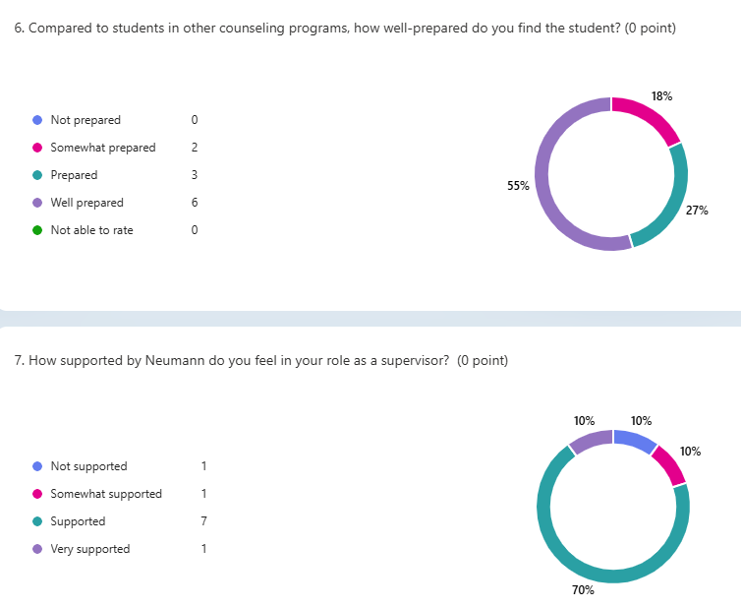
- “Based on your experience, would you consider supervising other students from Neumann? Please feel free to explain.”
  - All 11 responded very positively (e.g., “Always” “Sure, without hesitation” “Thoroughly enjoy”)
  - One limitation noted was the hours they are able to provide our students.
- Employer Survey:
- Only two alumni responded to the alumni survey, and only one of them supplied the optional contact for an employer, who did not respond to the employer survey.
- Again, in order to increase the number of responses, our program has implemented a new system to stay in touch with alumni so as to better track this data point.

Subsequent Program Modifications
The faculty engage in a regular, collaborative process of gathering and analyzing data for the program assessment plan. Our review of the past year of data has resulted in plans for more consistent and thorough data collection to support our new assessment plan as well as the following specific modifications.
- Tracking students post-graduation.
- Earlier gatekeeping / interventions to support students struggling with accountability.
- Regular monthly faculty meetings to discuss student concerns.
- Writing support is now offered through our university’s Writing Center.
- Developed a rubric for assessing student’s leading a group during their internships.
- Review and clarify instructions and expectations for student assignments and overall success.
We also continue to consider the following possible curriculum changes:
- Capstone course from final paper to final “portfolio.”
- Treatment of psychopathology course (separate from Psychopathology).
- Combine 505 Theology into 500 Introduction.
Finally, the CMHC program has maintained its CSI chapter, Alpha Omega Nu and inducted 9 new members. We also elected three student leaders who planned a service project and social hour for the students in the fall of 2024.
Substantial Program Changes
Some new faculty have joined us as others have departed. Sr. Suzanne Mayer officially retired after the Spring 2025 term, and Dr. Kate Worley departed as well. In their place, we welcomed Dr. Bentley Eskridge who started in the Summer 2025 and Dr. Lori Vien to start in Fall 2025. Dr. Tim Hanna accepted the role as Program Director and Academic Unit Leader, and Dr. Sophia Park has remained as Clinical Coordinator. We thus now have three full-time, core faculty (Drs. Hanna, Eskridge, and Vien) and one full-time, non-core faculty (Dr. Park). Our other major program change has been the implementation of our new assessment plan, which we will also be looking to update from aligning with 2016 CACREP standards to 2024 standards over the following year.

